Report: Soil Farming Agent Using MERN Stack and MongoDB
Problem Statement
The Soil Farming Agent project aims to address the critical role of soil in agriculture. Different types of soil support various crops, each with unique characteristics. To optimize crop growth, it is essential to understand these soil types and their traits. The proposed application will allow administrators to update information on the portal, including crop and seed distributor details, with input from soil and crop specialists. Users can view these soil and distributor details through the application.
Technologies Used
- Frontend: HTML, CSS, JavaScript, React.js
- Backend: Node.js, Express.js
- Database: MongoDB
- Hosting: Firebase
Project Modules
- Admin Module:
  - Admins can post soil details and distributor details.
  - Admins are responsible for updating information based on expert input.
- User Module:
  - Users can register and log in.
  - Users can view soil details and distributor details.
System Architecture
The architecture of the Soil Farming Agent application follows the MERN (MongoDB, Express.js, React.js, Node.js) stack structure, ensuring modularity, scalability, and maintainability.
- Frontend: Developed using React.js, which provides a dynamic and responsive user interface.
- Backend: Implemented with Node.js and Express.js, enabling robust handling of API requests and business logic.
- Database: MongoDB is used for its flexibility in handling various types of data and ease of integration with Node.js.
- Hosting: Firebase is used for deploying the application, ensuring reliable and scalable hosting solutions.
Project Development
- Code Modularity: The project is developed in a modular fashion, adhering to coding standards to ensure the code is safe, testable, maintainable, and portable.
- GitHub Repository: The codebase is maintained on a public GitHub repository, complete with a detailed README file outlining the project's workflow and execution.
- Logging: Comprehensive logging is implemented for every action performed by the code, utilizing JavaScript logging libraries.
Optimization and Testing
- Code Optimization: Efforts are made to optimize the code to enhance performance and efficiency.
- Architecture Optimization: The system architecture is designed to handle large data sets and user interactions efficiently.
- Test Cases: Detailed test cases are created to ensure the functionality and reliability of the application.
Submission Requirements
- GitHub Repository: The complete code is submitted to a public GitHub repository.
- Detailed Project Report: A comprehensive project report is created, documenting the project development process, system architecture, and optimization strategies.
- System Architecture Design: The wireframe and architecture documents are submitted, detailing the system's design.
- Test Cases Documentation: All test cases are documented and included in the final submission.
Conclusion
The Soil Farming Agent application leverages the MERN stack and MongoDB to provide a robust platform for managing soil and crop information. The use of modern technologies ensures the application is scalable, maintainable, and user-friendly, meeting the project's requirements effectively.
PROJECT SCREENSHOTS
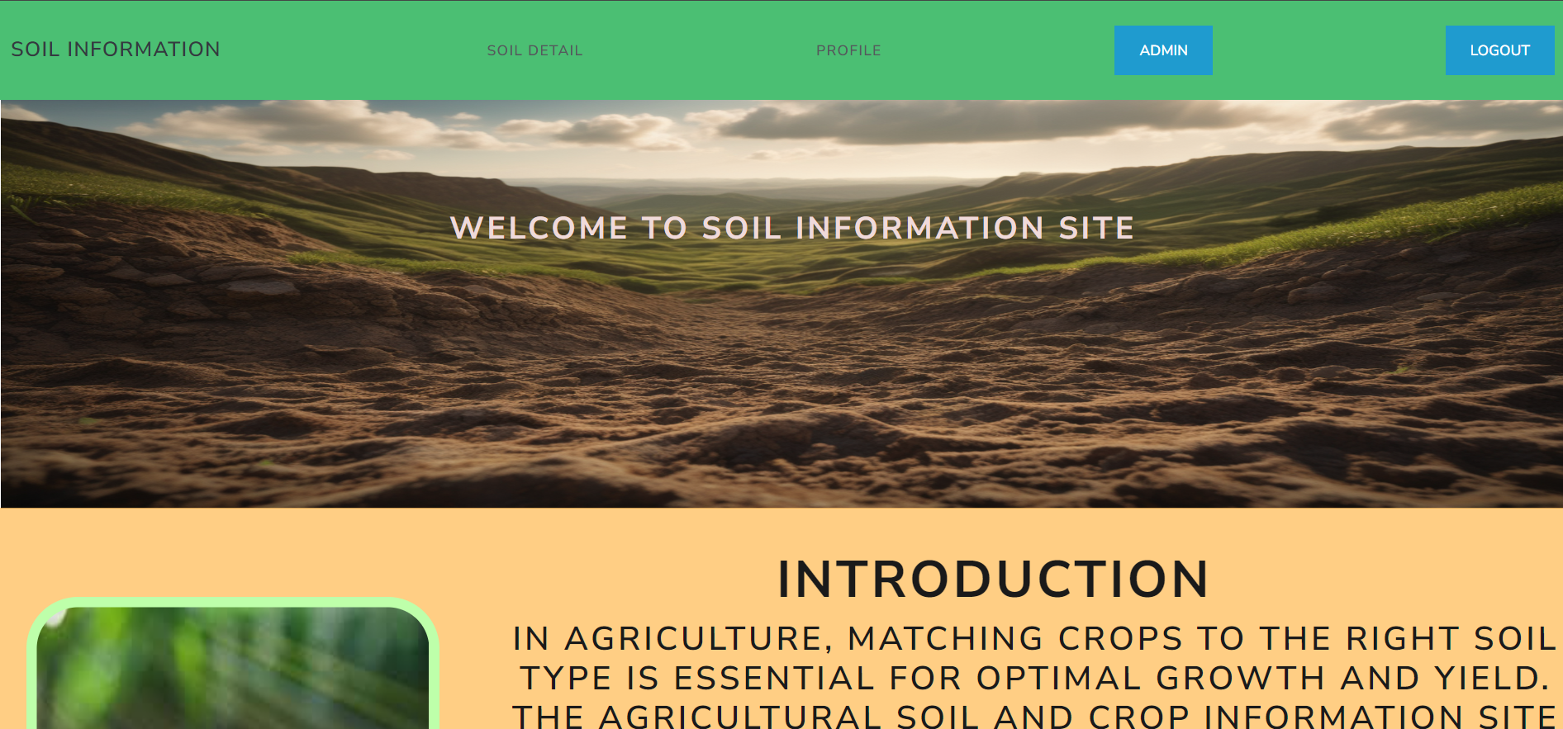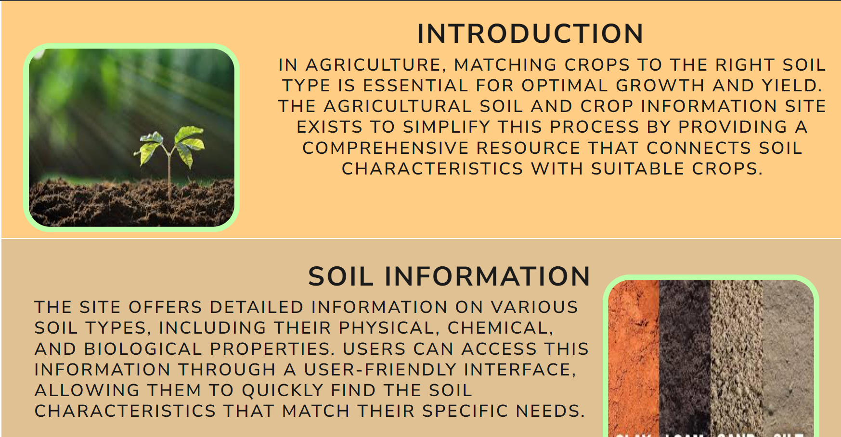
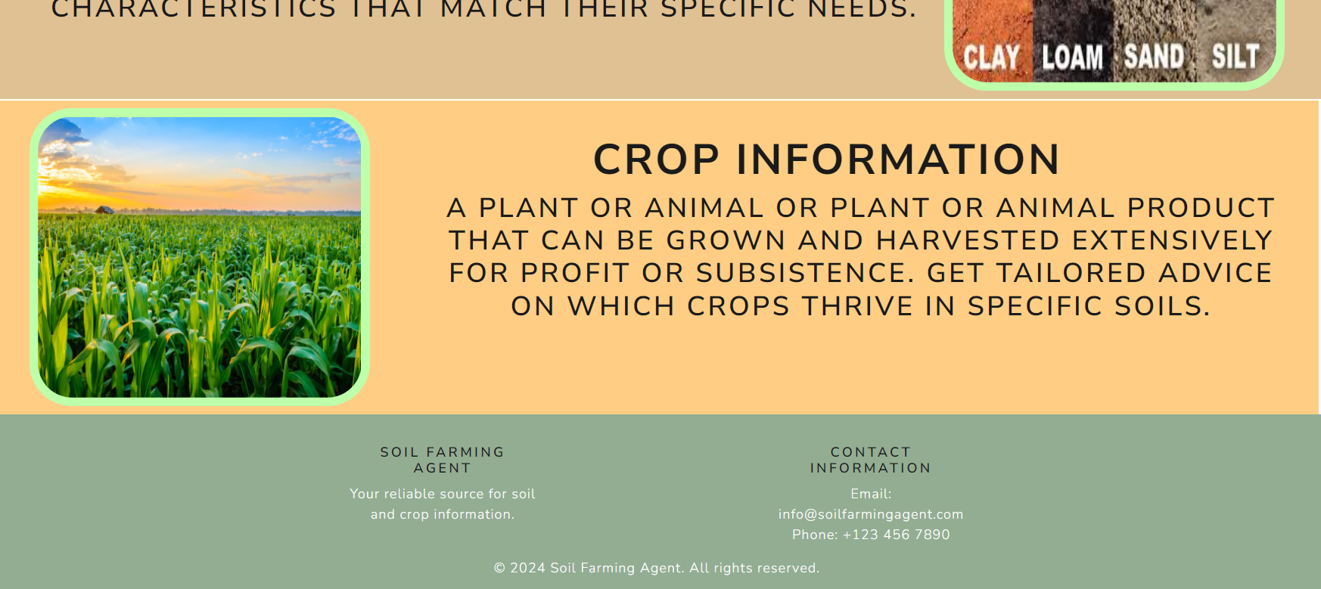
HOME SCREEN
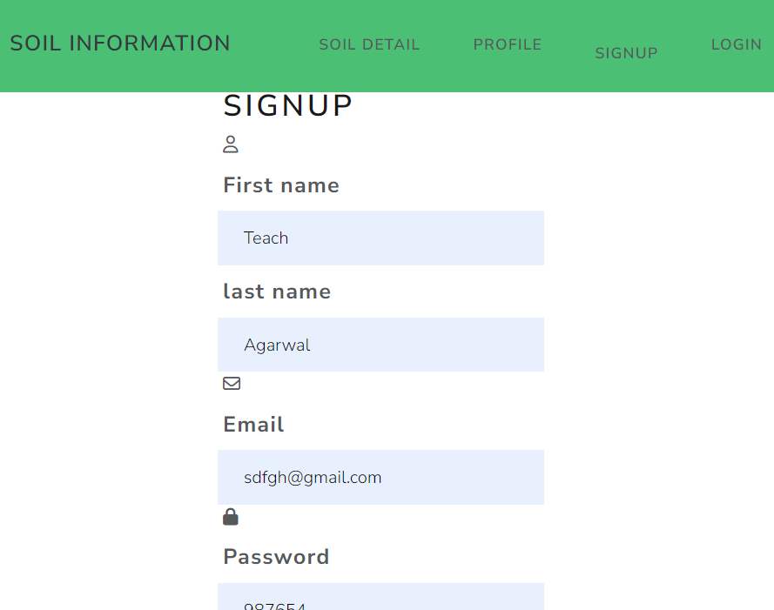
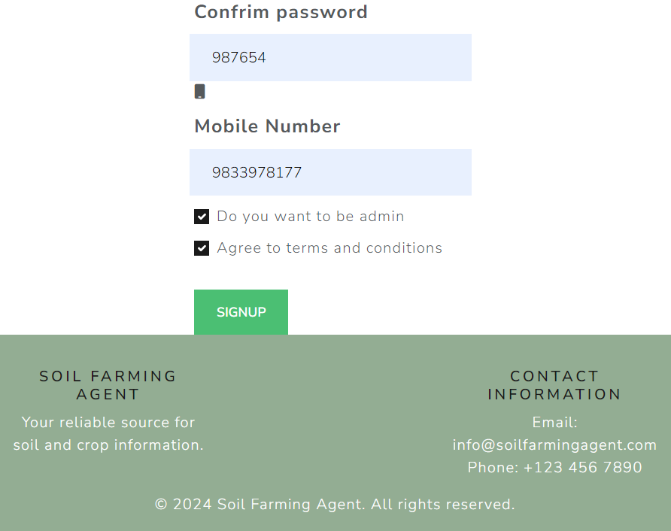
Signupscreen
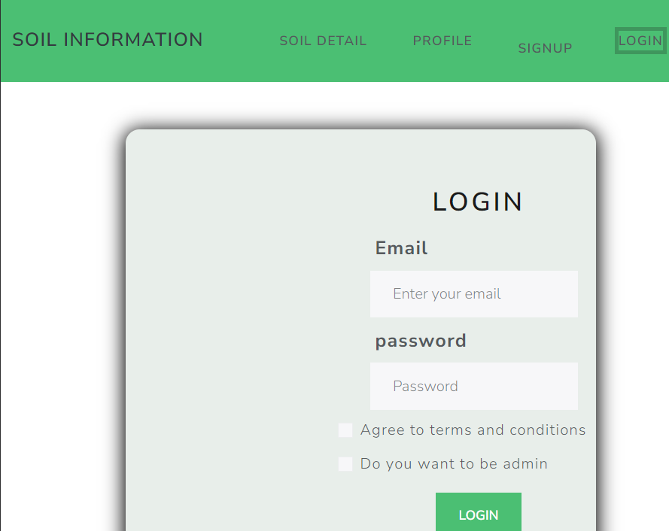
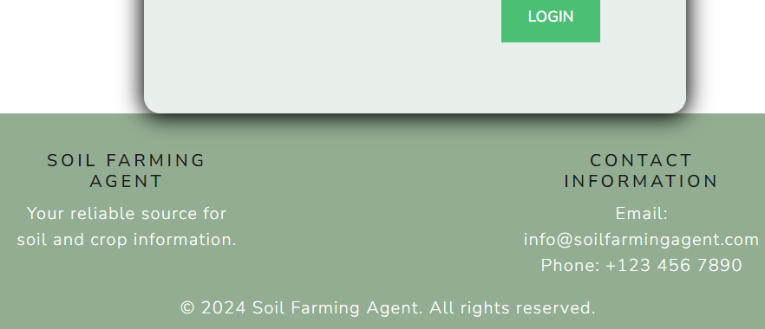
Login Page
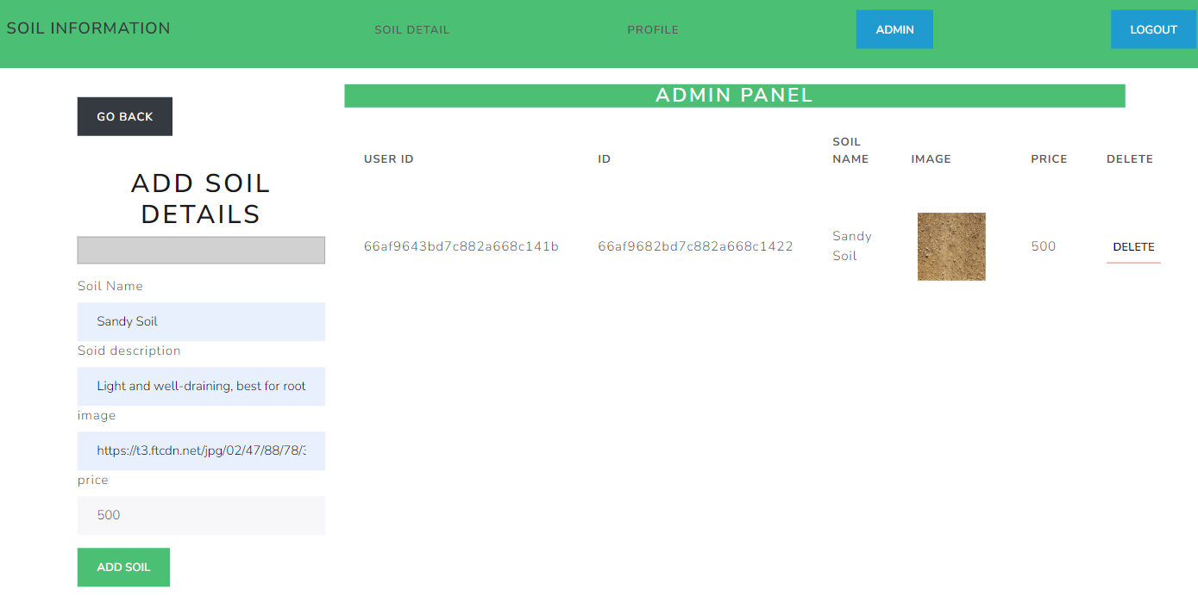
Admin Panel
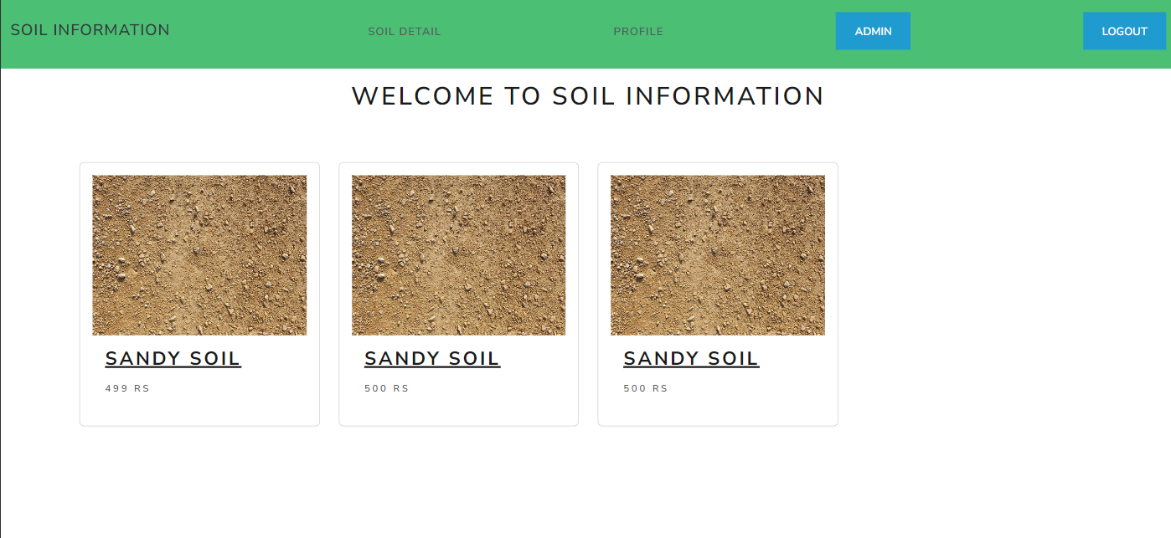
Soil Information
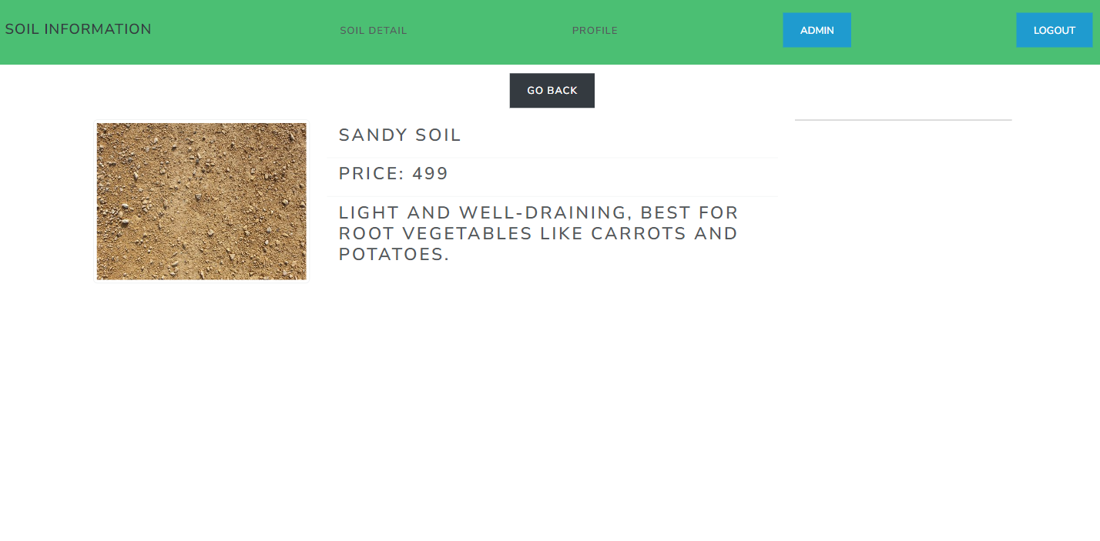
detail Soil page

